Memory management

1).Setup additional swap space in the system to solve low memory issue. The swap which you added should be available post reboot.

On a virtual machine we need to create a swap partition (you might need an extra virtual disk for this).

Adding 20 **MB** swap file to the system.

dd if=/dev/zero of=/swapfile20mb bs=1024 count=20000

20000+0 records in

20000+0 records out

20480000 bytes (20 MB) copied, 0.0446642 s, 459 MB/s

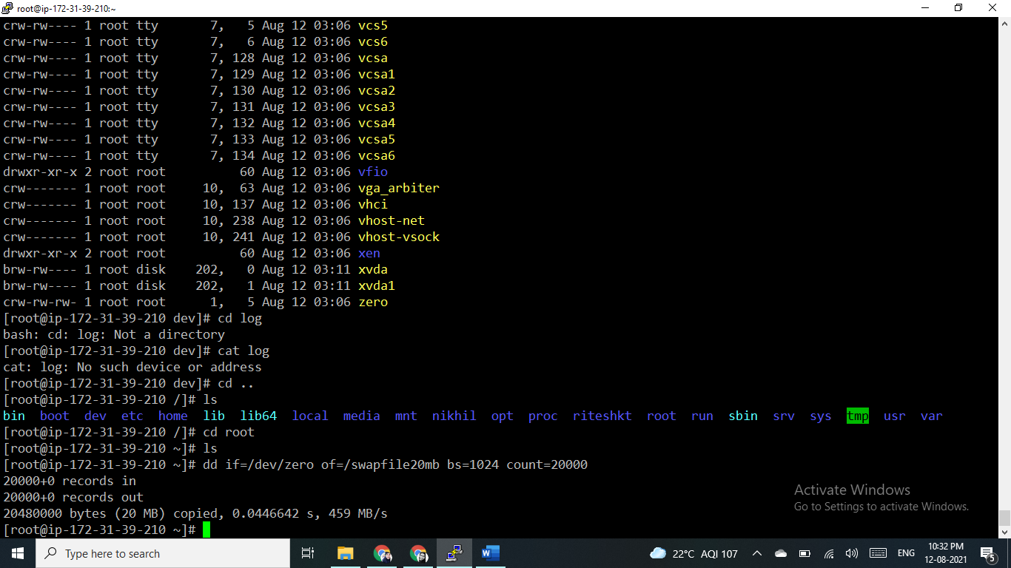

mkswap /swapfile20mb

mkswap: /swapfile20mb: insecure permissions 0644, 0600 suggested.

Setting up swapspace version 1, size = 19.5 MiB (20475904 bytes)

no label, UUID=75e90234-24fc-4297-bebf-455c64f7b0e0

swapon /swapfile20mb

swapon: /swapfile20mb: insecure permissions 0644, 0600 suggested.

[root@ip-172-31-39-210 ~]# free -m

total used free shared buff/cache available

Mem: 983 105 447 0 429 737

Swap: 19 0 19

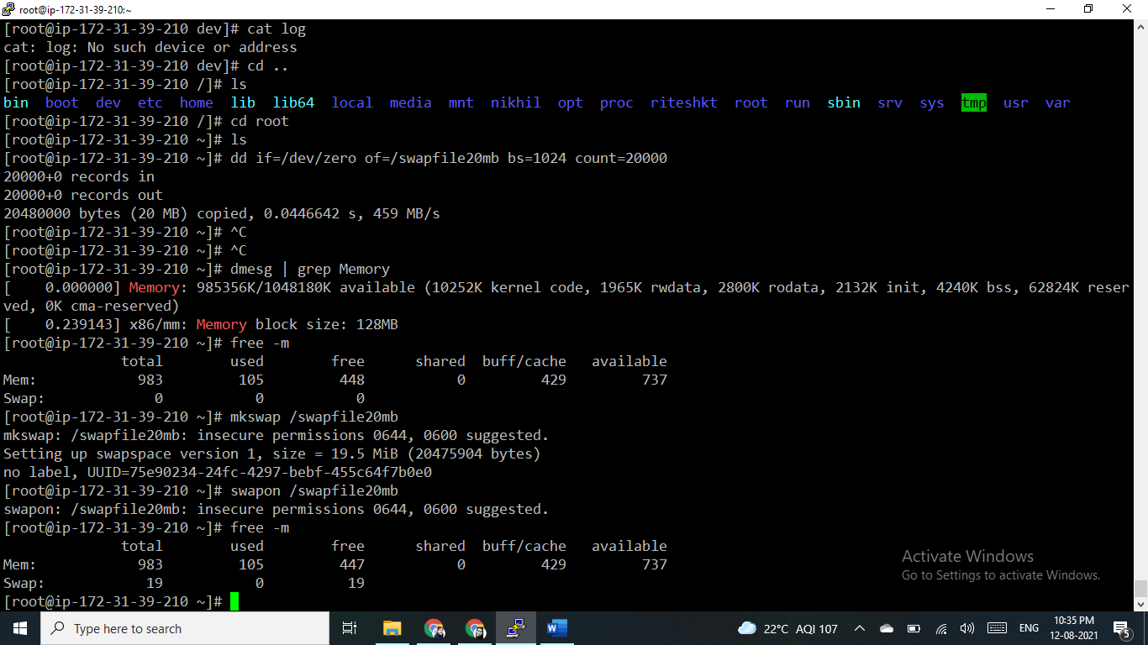

Create a file that will be used for swap:

sudo fallocate -l 20mb /swapfile20mb

If faillocate is not installed or if you get an error message saying fallocate failed: Operation not supported then you can use the following command to create the swap file:

sudo dd if=/dev/zero of=/swapfile20mb bs=1024 count=20000

Only the root user should be able to write and read the swap file. To set the correct [permissions](https://linuxize.com/post/chmod-command-in-linux/) type:

sudo chmod 600 /swapfile20mb

Use the mkswap utility to set up the file as Linux swap area:

sudo mkswap /swapfile20mb

Enable the swap with the following command:

sudo swapon /swapfile20mb

To make the change permanent open the /etc/fstab file and append the following line:

/swapfile20mb swap swap defaults 0 0

To verify that the swap is active, use either the swapon or the [free command](https://linuxize.com/post/free-command-in-linux/) as shown below:

sudo swapon –show

sudo free -h

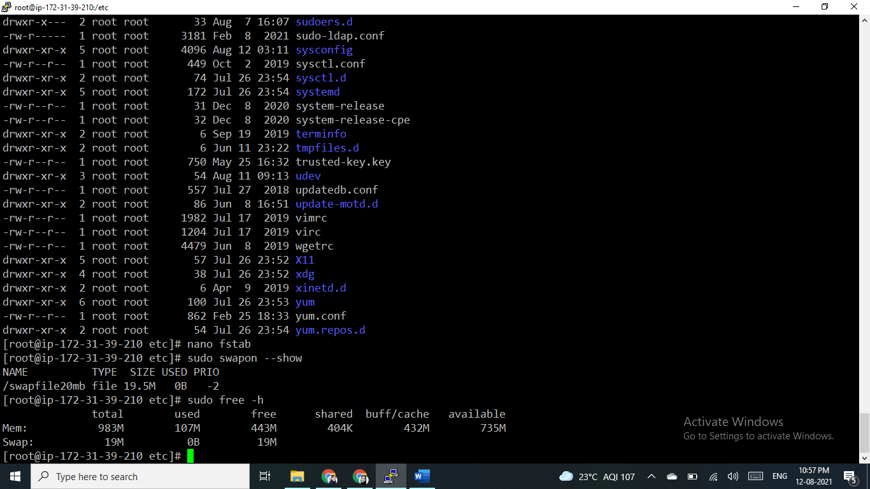

After restart the server it is mounted and swap is available.

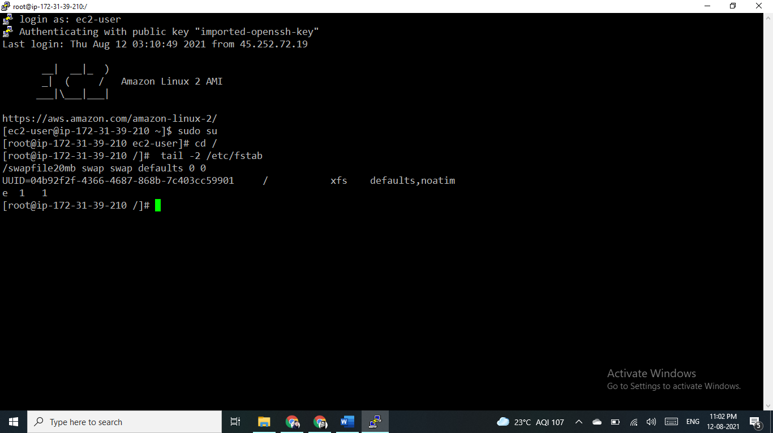

2) Find out the number of process is in run queue and blocking queue

No of process in Running Queue and Blocking Queue

To quickly list running/blocked processes use below ps command:

ps r -Af

[root@ip-172-31-39-210 etc]# ps r -Af

UID PID PPID C STIME TTY STAT TIME CMD

root 3346 3185 0 18:08 pts/0 R+ 0:00 ps r -Af

